# AutoTest Studio Getting started tutorials 5: Preset Use Cases

Pre-built use cases allow you to do some additional things before and after the test task or test case runs, for example, check the environment or set certain parameters before the task runs, and clean the environment or restore parameter settings after the task runs.

AutoTest Studio provides four types of preset use cases.

**BeforeTask**, it is executed at the beginning of each task, that is, it is executed before all use cases are run.

**BeforeCase**, execute before each use case runs.

**AfterCase**, execute after each use case is run.

**AferTask**.Execute at the end of each task, that is, execute after all use cases have run.

After creating a new project, there will be four default folders in the "Presets" interface by default, corresponding to the four preset use case types, as shown in the figure below.

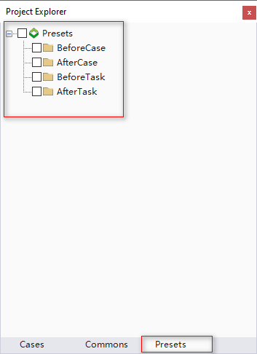

Users only need to write the corresponding use cases in the corresponding folder. You can write multiple use cases in the same type, or none, depending on your needs.

Here we write two use cases for each type to demonstrate the calling sequence of the preset use cases. The content of the use cases can be written at will, and the way of writing preset use cases is no different from that of ordinary use cases.

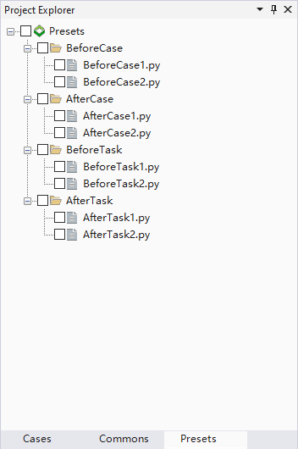

In the settings, we choose to count all types.

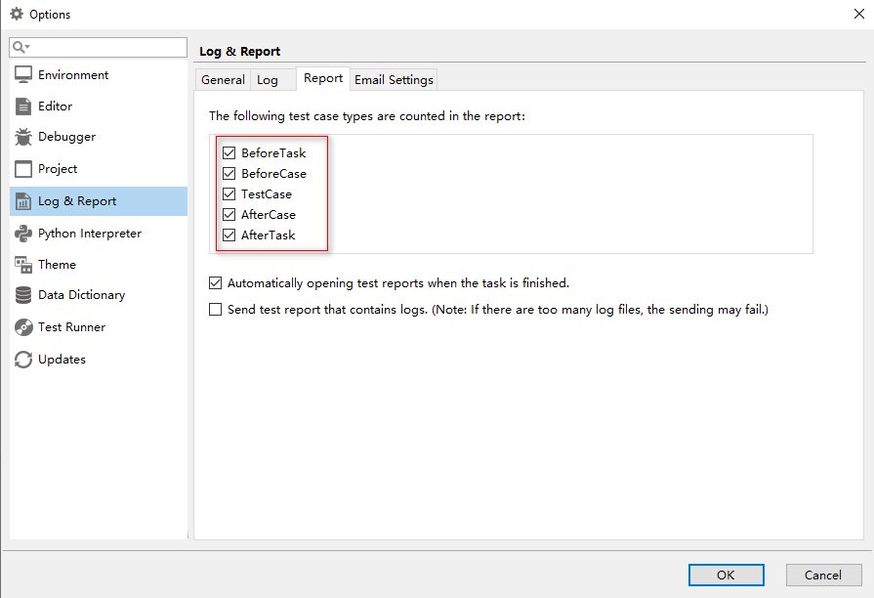

Before the task is executed, we only need to check one or more preset use cases that need to be run. Of course, we can also select none of them. For demonstration, we check as follows.

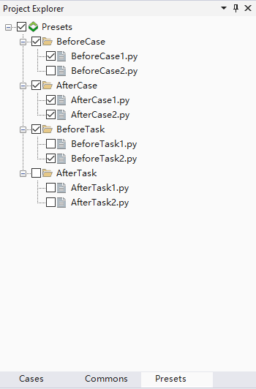

Select the use case to execute the task once, and the execution result is as follows.

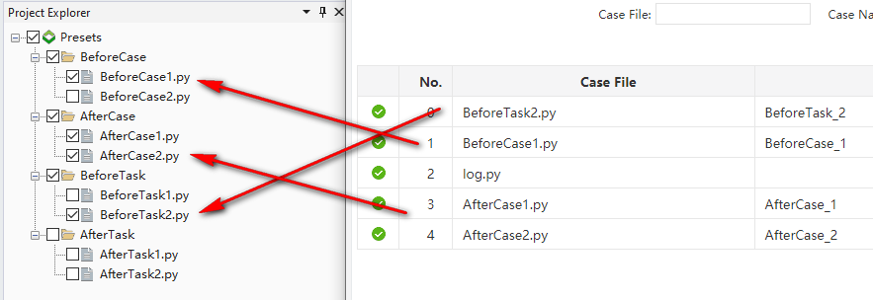

As can be seen from the above screenshot, the preset use cases we selected are executed in accordance with the correct logic. There is no preset use case to be executed in the AfterTask directory, so there is no corresponding record in the log.

Let's execute it again, check all the preset use cases in the example, and check the multiple use cases written in the previous chapters to see the effect.

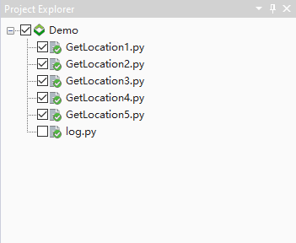

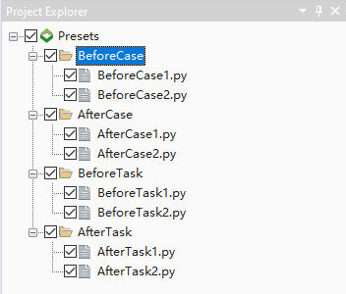

The results of the operation are as follows (note that the preset use cases are executed before and after each use case is run).

